**UAT Testing**

**Introduction**

Purpose

The purpose of the test is to ensure that the games meet the main mechanics. I need to ensure they are both user friendly and functional.

Scope

I want to test the functionality of the movement and if it is user friendly enough to be playable and enjoyable. I need to know if the mechanic is functioning correctly and if there are any major issues that should be looked into.

Mechanics to test

Movement:

Moving at different forces

Different directions

Can not directly move backwards without bouncing

Respawn / Lives

The player should respawn when they get out of bounds

The lives should update accordingly

Objectives

I want to make sure that the main features, such as moving and aiming the ball are all functional as intended. I will be looking at how User-friendly the mechanics are.

**Test Preparation**

Test plan

I am going to focus on observing the players rather than directing them towards an outcome. If there is a specific mechanic I want to be tested I will ask them to try something specific. After they have played I will just ask for feedback directly and for their thoughts on their experience.

For my test cases I am mainly focused on the movement of the ball. And I will also observe how clear it is to the player on what they can do.

Can the user move the ball forwards?

Moving at an Angle

Move the ball at different strengths

Cannot move the ball backwards unless bounced

Does the user respawn when out of bounds

Test Environment

The testing environments I will be using are:

**My Phone**: Running android 14

**Execution and Evaluation**

User 1 Palin

**Functionality**

Found an issue where you can bounce over the barriers which can sometimes cause you to go out of bounds, however the respawn functionality works correctly so they were respawned at the beginning of the obstacle.

Movement worked as intended for the most part.

|  |  |
| --- | --- |
| Test Case | Status |
| Can the user move the ball forwards? | Yes |
| Moving at an Angle | Yes |
| Move the ball at different strengths | Yes |
| Cannot move the ball backwards unless bounced | Yes |
| Does the user respawn when out of bounds | Yes |

**Usability**

It wasn’t immediately clear on how to move the ball, figured out without directions

The Scoring system was confusing, wasn’t clear on what it was supposed to be represented by.

Its not clear that the ball can be moved again while it is still moving

The lives were clear for purpose after respawning.

**Overall Experience**

Enjoyed the game overall,

Suggestions: A reset button so the player can be teleported back to the checkpoint when stuck in a corner

Bugs

No arrow:

Can Bounce over barrier

No level 3

User 2 Grayson

**Functionality**

Movement working correctly, also encountered where you can bounce over the barriers

|  |  |
| --- | --- |
| Test Case | Status |
| Can the user move the ball forwards? | Yes |
| Moving at an Angle | Yes |
| Move the ball at different strengths | Yes |
| Cannot move the ball backwards unless bounced | Yes |
| Does the user respawn when out of bounds | Yes |

**Usability**

Again, Initially attempted to swipe upwards for movement It wasn’t immediately clear on how to move the ball, figured out without directions

The Scoring system was confusing since it didn’t update every shot

The changing colors wasn’t making this clear either

Its not clear that the ball can be moved again while it is still moving

The lives were clear for purpose after respawning.

**Overall Experience**

Enjoyed the game

Suggestions: The Score should update for every shot.

Bugs

No arrow:

Can Bounce over barrier

No level 3

User 3 Kyle

**Functionality**

Movement working as intended

Could bounce out of bounds, the arrow didn’t appear, level 3 not loading

|  |  |
| --- | --- |
| Test Case | Status |
| Can the user move the ball forwards? | Yes |
| Moving at an Angle | Yes |
| Move the ball at different strengths | Yes |
| Cannot move the ball backwards unless bounced | Yes |
| Does the user respawn when out of bounds | Yes |

**Usability**

It wasn’t immediately clear on how to move the ball, figured out without directions

The colour gradient is clear to describe force behind the shot.

**Overall Experience**

Suggestions:

Centering the text in the scores menu,

User 4 Erika

**Functionality**

Could bounce out of bounds, the arrow didn’t appear, level 3 not loading

|  |  |
| --- | --- |
| Test Case | Status |
| Can the user move the ball forwards? | Yes |
| Moving at an Angle | Yes |
| Move the ball at different strengths | Yes |
| Cannot move the ball backwards unless bounced | Yes |
| Does the user respawn when out of bounds | Yes |

**Usability**

Once again , It wasn’t immediately clear on how to move the ball, figured out without directions

The outline on the end screen text made it easier to read

**Overall Experience**

Making it clear how to move the ball at the start of the level.

The ball should have to stop before the player can move it again, the scoring system should track every shot rather than specific ones.

Suggestions: the high score should be visible while playing, to give players motivation to try and get a better score.

**Bugs Encountered by all users.**

The arrow doesn’t appear at the start of the game, to reproduce just open the game and press start. Their should be an arrow to help users be able to know how to move the ball.

If timed correctly a shot can be made in mid-air to jump over the barriers.

Level 3 is not loading correctly.

**Reporting**

Summary

All 4 users initially attempted to swipe upwards to move the ball. I believe this is primarily because the arrow indicator did not appear in the testing process. I think if the arrow did appear it would have made it clearer to all the users about the movement functionality

The scoring system needs to be changed so it counts each individual shot rather than in sections as none of the users found the scoring system clear and thought it was functioning incorrectly.

All Bugs

**The Indication arrow did not appear at the beginning of the level.**

I believe this is caused when the input is received on the start button it is registered in the next scene and hides the arrow. The reason I think this is because the arrow is shown in the scene view and if I load a level directly from the editor. However playing from the menu causes the arrow to be hidden.

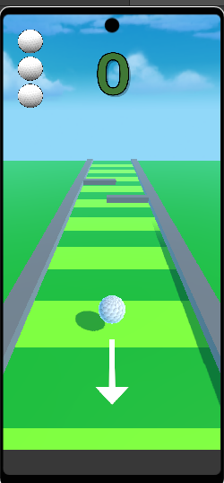

This is what the level should look like when it loads, however instead it loads without the arrow indicator

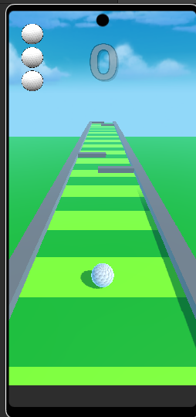

**Level 3 not loading**

The scene wasn’t added to the build settings. There is a error prevention in the code to load the main menu if the next level does not exist and in the version that was being tested the build settings weren’t updated to include level 3.

**Bouncing out of bounds**

From observation it isn’t game breaking , however my plan to fix this bug would be to lower the sensitivity of the physics and add invisible barriers to the sides and near the obstacles so the ball cannot get out of bounds at all.

**Future Improvements**

The ability to manually respawn ws suggested , so when the player is stuck in a corner, there would be a button to respawn to the middle of the track.

Extending the variation of the levels would improve the re-playability of the game.

Adding additions such as corners would make the levels more interesting.

Larger range of obstacles and improved level design

Another suggestion was to help with the ball getting stuck on the side so an ability to rotate the camera would allow the player to be able to aim more precisely.

From the user feedback I think I would make the scoring system more standard and have each shot count towards one point rather than only increasing in the obstacle sections.

For re-playability it was also suggested that the high score should be visible while playing, to give players motivation to try and get a better score.